**UNITY New User Setup and New User 1st Time Login**

**Doc Date: 2-20-2025**

**Objective: How To setup a UNITY user and communicate the login process for a new UNITY user**

**Components:**

* **ICJO creates a new user profile in UNITY**
* **New user UNITY account setup process**
  + **New User receives 2 separate emails**
    - **Welcome Email**
    - **Temporary Password Email**
  + **New User with the Login Name & Temporary Password**
    - **Accesses UNITY**
    - **Accepts “Privacy Policy” and “End User Agreement”**
    - **Completes and carefully reviews the setup of their UNITY User Profile**

**ICJO Creation of New User UNITY Account**

* Under the Administration menu select User and then select New User
* In the New User UNITY screen the ICJO completes all required data fields, double checks their accuracy, and selects Create New User. This action triggers the process steps for the new UNITY user.
* ICJO shares with the UNITY user the “**UNITY New User Setup and New User 1st Time Login”** document

**The new UNITY Account Setup Process**

* **The new UNITY user receives two emails**

Welcome to UNITY “Email”

* Provides UNITY URL
* Provides UNITY Username
* Provides UNITY User Profile Setup Guidance

UNITY – Temporary Password “Email”

* Provides the UNITY access Temporary Password
* Provides UNITY User Profile Setup Guidance
* **Using the email instructions the new user logs into** [**https://www.icjunity.org/**](https://www.icjunity.org/) **& resets their password.**

Reset Your Password  The new password must be 8 characters long and include the below

* 2 special characters
* 2 lower case characters
* 2 upper case letters
* 2 special characters
* **Upon completion of the password reset, the user reads & completes the 2 UNITY consents.**

Read and complete 2 Consent Requirements: Toggle “Yes” and Select the “Agree” button

* UNITY Privacy Policy
* UNITY User Agreement
* **Review and Setup your Profile:**

Review and Setup your Profile Page by following each of the following steps

* Review your “Demographics” panel
* Toggle the Task Grid Options in the “Task Grid Preferences” panel
* Complete the following in the “Communication” panel
  + Toggle On Email Notifications
  + Select “Verify Email”
    - Select “Save and then verify email”
  + Logout of UNITY and complete Email Verification process before continuing the final setup steps
* Setup your 3 Security Questions in the “Questions” panel
* Set “MFA Method” to Email in the “MFA” panel
* Select Save in your profile and then Logout of UNITY
* Log back into UNITY using the MFA process

**Welcome to UNITY “Email”** Back to Top

**UNITY – Temporary Password “Email”**

**Login using emailed “Login” & “Temporary Password”**  Back to Top

<https://www.icjunity.org/>

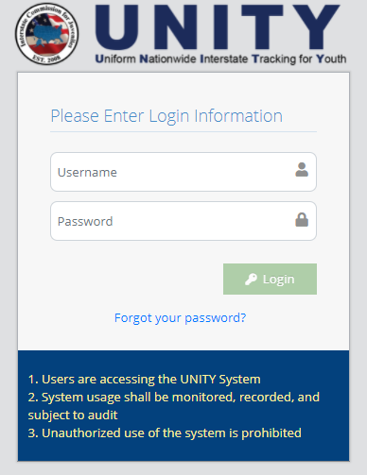

**Update Your Password & click on ”Reset Password”**

* Use the Temporary Password as the “Current Password” and create a new password
  + 2 special characters
  + 2 lower case characters
  + 2 upper case letters
  + 2 special characters
* Click on Reset Password

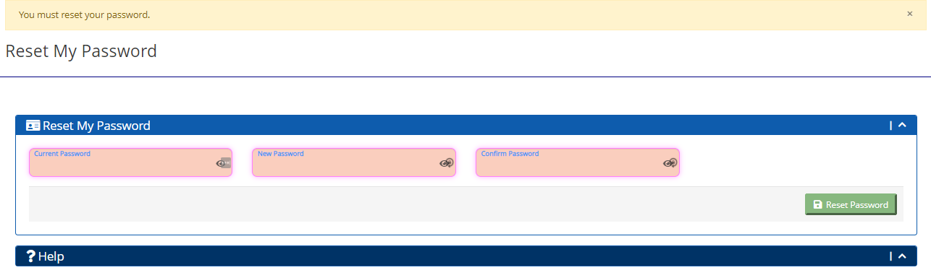

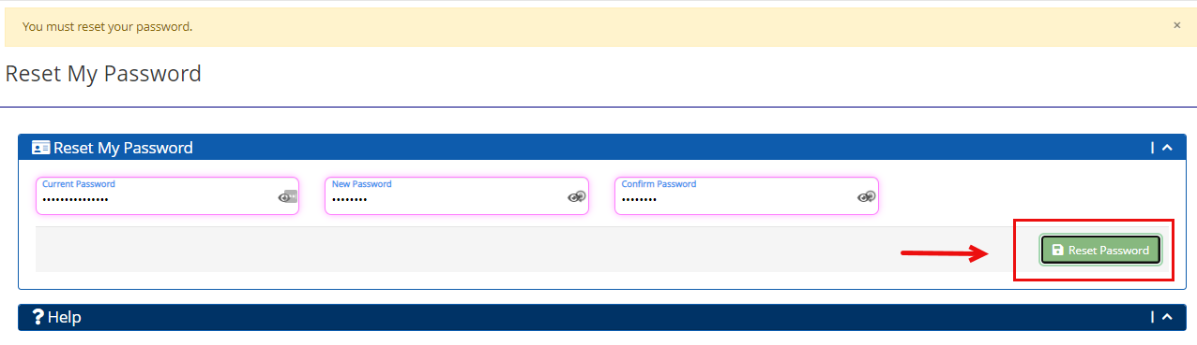

**Thoroughly Read and Toggle “Agree” to “Yes” for the  “Consent: UNITY User Agreement” and the “Consent: ICJ 2021-02 UNITY Privacy Policy Rev May 23 2024”** Back to Top

**Review and Setup your Profile in the following order:**

* -1- Demographics Panel

* + Review and Update your Demographics as needed
* -2- Task Grid Panel
  + Toggle On your Task Grid Options
* -3- Communication Panel
  + Toggle On Email Notifications
  + Click on “Verify Email”
    - Click on “Save and then verify email”
  + Complete Email Verification process
    - **Logout of UNITY**
    - Obtain new email in your Inbox
    - Use the Link & Password to Verify your account
    - Once Verified, complete the profile setup
* -4- Challenge Questions Panel
  + Setup your 3 Security Questions
* -5- MFA Panel (Multi-factor Authentication)
  + Set “MFA Method” to Email
  + Save
  + Logout of UNITY
  + Log back into UNITY using the new MFA process

**-1- Demographic Panel**

**-2- Task Grid Preferences Panel**



**-3- Communication Panel**

**Toggle “Email Notifications”**

**Verify your email**

* + Click on “Verify Email”
    - Click on “Save and then verify email”
  + Complete Email Verification process
    - **Logout of UNITY**
    - Using the new Verification email in your Inbox
      * Use the Link & “Verification Code” to Verify your email
      * Click on “Save”
      * Once Verified, complete the profile setup

**Communication Panel……continued**

**-4- Challenge Questions Panel**

* + Setup 3 challenge questions so that you can self-service for a password reset when locked out without having to engage your state ICJO or submit a support case.

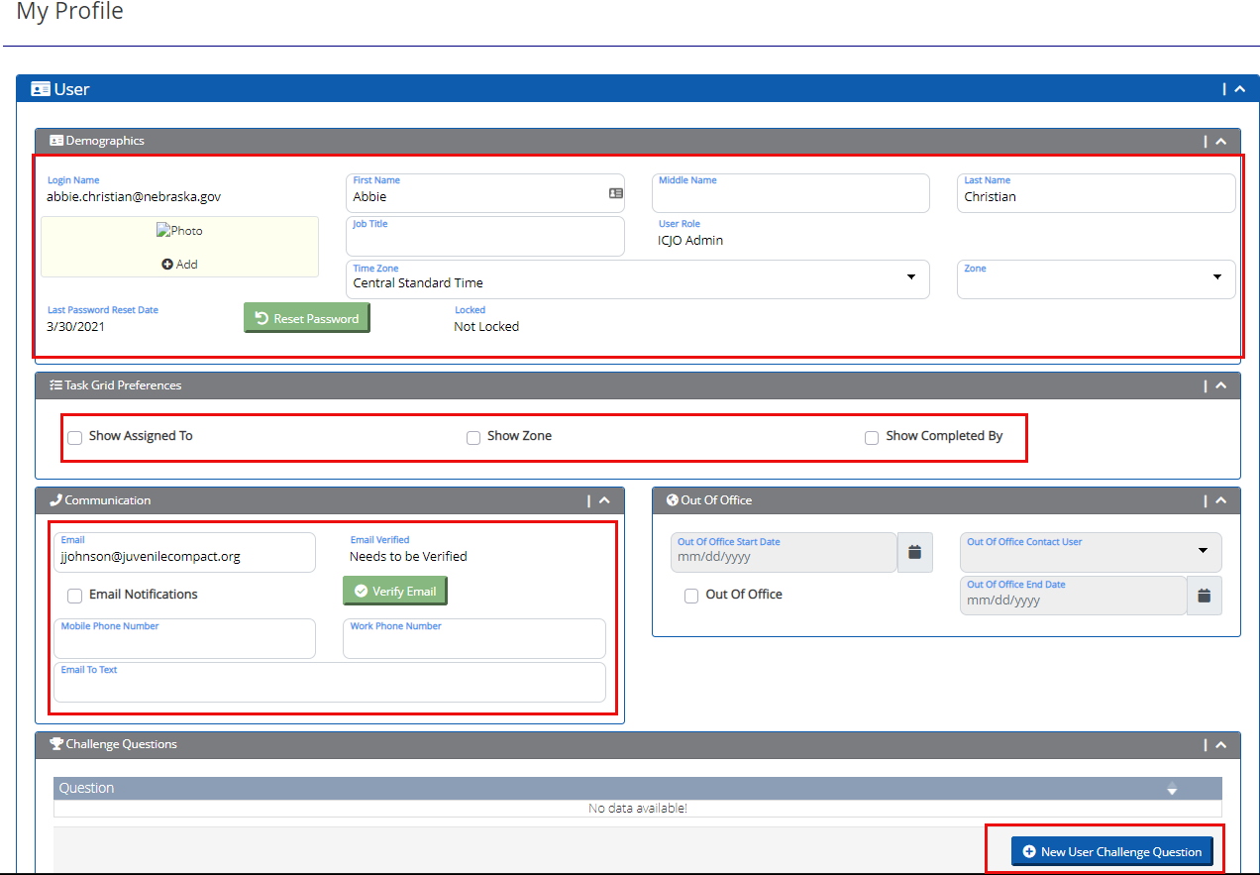

**-5- MFA (Multi-factor Authentication) Panel**

* Multi-factor authentication (MFA) is a security measure that requires users to provide multiple pieces of information, like a password and a code sent to their email or phone, to access an account, significantly reducing the risk of unauthorized access even if one piece of information is compromised, making it a crucial tool for protecting sensitive data online.
  + It is recommended that you initially start with “Email” as indicated in the below instructions.

* **When you have completed the careful review of your “Profile” page and Selected “Email” in the “MFA Method” dropdown, click the “Save” button.**

Click on the  button.

* **Go to the top right corner of the “Profile” page and “Logout” of your UNITY system.**

* **Go to the UNITY login page and log back into UNITY.**
  + Once logged in you will be redirected to “Please Enter Code from Email”.

**MFA Panel ………..continued**

* **Go to your email, you will receive an email with the 6-digit code to use in the “Verification Code” box.**

* **Carefully type or copy/paste this code into the “Please Enter Code from Email” box & click on “Submit”.**

* **You are now logged into UNITY and you will use this “Enter Code from Email” process each time you log into UNITY**

**Help & Support**

* Your State ICJ Office Staff is listed in the “Help” panel at the bottom of each UNITY page
* ICJ National Office UNITY support can also be obtained using the following URL or email
  + https://support.juvenilecompact.org/hc/en-us/requests/new
  + [support@juvenilecompact.org](mailto:support@juvenilecompact.org )

